Working Case
(Sender Process)
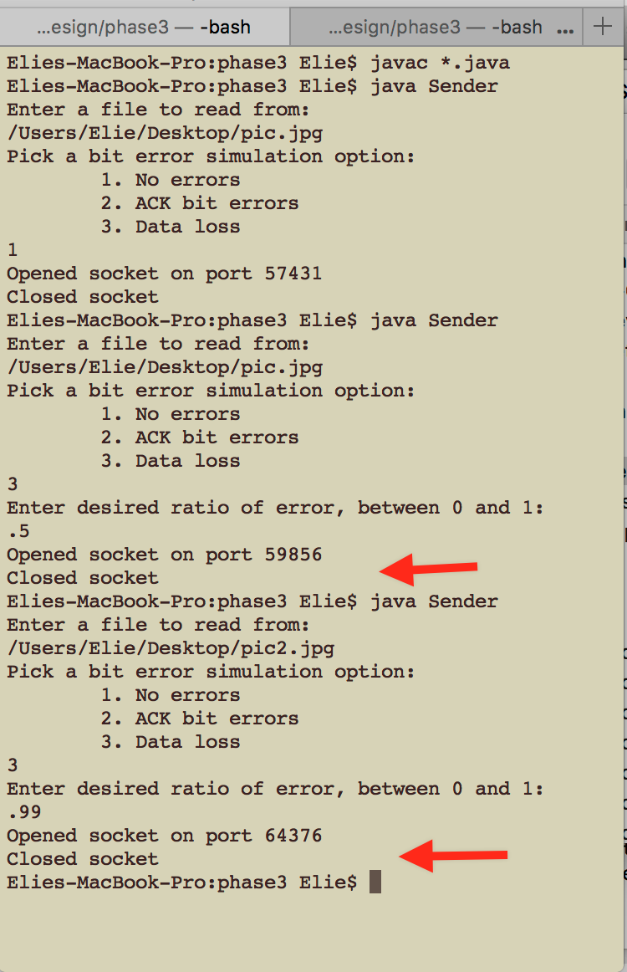 there was a lag at the two arrows to show that transmission time took longer. The lags are not visible in this screenshot (pic2.jpg is 939KB, pic.jpg is 283KB)

(receiver process)
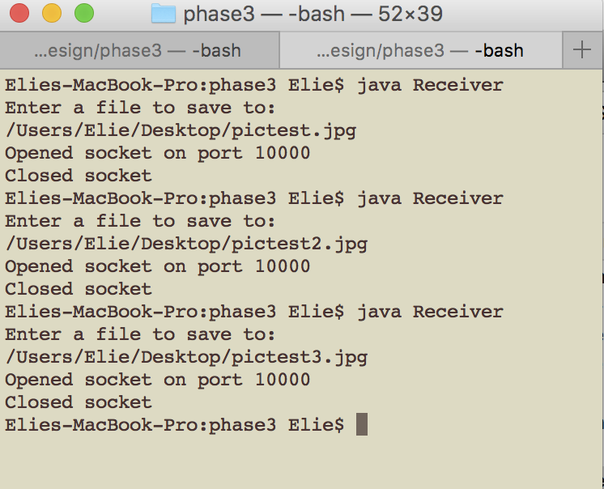

Design – classes and purposes

StateMachine – sets up the generic state machine class that is needed for both receiver and Sender
ReceiverStateMachine – establishes a state machine for the receiver, establishes where the incoming packet will be saved, collects the packet from the incoming messages, checks the checksum and sequence number and extracts the data. The receiver state machine takes each incoming packet as an “event” that it will then use to decide what to do and what state to change to using function .delta)
Receiver – instantiates a receiver process, establishes where the incoming file will be saved, boots up a receiveManager process
receiveManager – opens the socket to listen for packets. Declares a new ReceiverStateMachine and a new receivedPacket, then advances through the states of the receiving machine
receivedPacket – make a checksum for the received packet, compares it to the given checksum in the header to see corruption,
SendingStateMachine – does the same as receiverStateMachine, but in addition, it also, manipulates the received ack and the sent data to simulate a bit error
Sender- instantiates a sender process, what file should be sent, establishes how much bit error, if any, there will be boots up a sendManager process
SendManager – establishes the socket to listen on, instantiates a SendingStatemachine
ServerReceived- checks the checksum of the ack as well as the sequence number, checks if it’s corrupted

